**Exercise 10: Implementing the MVC Pattern**

Overview

* The Model-View-Controller (MVC) pattern is used to separate an application's concerns into three interconnected components. This exercise demonstrates the implementation of MVC for a simple student management system.
* File Structure
  + Student.java (Model)
  + StudentView.java(View)
  + StudentController.java (Controller)
  + MVCTest.java (Main application)
* Implementation Details
* 1. Student.java (Model)
* This file represents the data model of a student.
* Key features:
  + Private attributes: name, id, and grade
  + Constructor to initialize all attributes
  + Getter and setter methods for each attribute
* The Student class encapsulates the data and provides methods to access and modify this data, adhering to the principle of data hiding.
* 2. StudentView.java (View)
* This file is responsible for displaying student information to the user.
* Key features:
  + displayStudentDetails method: Takes student information as parameters and prints it to the console
  + No direct connection to the model, ensuring separation of concerns
* The StudentView class focuses solely on how to present data to the user, without any knowledge of how the data is stored or manipulated.
* 3. StudentController.java (Controller)
* This file acts as an intermediary between the Model and the View.
* Key features:
  + Private attributes: model (Student) and `view` (StudentView)
  + Constructor that initializes both the model and view
  + Methods to update student information in the model
  + updateView method to refresh the view with current model data
* The StudentController class manages the flow of data between the model and the view. It updates the model when changes occur and refreshes the view to reflect these changes.
* 4. MVCTest.java
* This is the main application file that demonstrates the use of the MVC pattern.
* Key features:
  + Creates instances of Model, View, and Controller
  + Provides a user interface to interact with the student management system
  + Uses a loop to allow multiple updates to student information
  + Demonstrates how the controller mediates between user input, model updates, and view refreshes

How It Works

* The MVCTest class creates a Student object (model), a StudentView object (view), and a StudentController object (controller).
* It then enters a loop where the user can input commands to update student information.
* User inputs are processed by the MVCTest class, which calls appropriate methods on the controller.
* The controller updates the model and refreshes the view as necessary.
* This cycle continues until the user chooses to exit.

Benefits of This Implementation

* Separation of Concerns: Each component has a distinct responsibility, making the code more organized and easier to maintain.
* Modularity: Changes to one component (e.g., the view) don't require changes to others, as long as the interfaces remain consistent.
* Flexibility: It's easy to add new views or change the underlying model without affecting other parts of the application.
* Testability: Each component can be tested independently, facilitating unit testing.

Potential Improvements

* Implement error handling for invalid user inputs.
* Add data validation in the model to ensure data integrity.
* Create multiple views (e.g., console view, GUI view) to demonstrate the flexibility of the MVC pattern.
* Implement a data persistence layer to save and retrieve student information.

Implementation

Link: [click here for the code.](https://github.com/Akashmondal55/Akash_5016855/tree/main/Week-1/Design%20patern%20and%20princple/Exercise-10)

Output

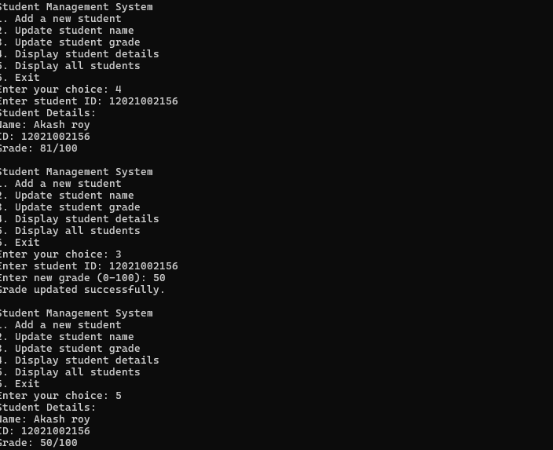

Conclusion

* This implementation of the MVC pattern demonstrates a clear separation of concerns in a simple student management system. By dividing the application into Model (Student), View (StudentView), and Controller (StudentController) components, we've created a structure that's both modular and extensible.
* The MVCTest class serves as a client that interacts with the MVC structure, showcasing how these components work together in a real-world scenario. This pattern allows for independent development and testing of each component, making the codebase more maintainable and adaptable to change.
* While this is a basic implementation, it lays the groundwork for more complex applications where the benefits of MVC become even more apparent, such as in web applications or large-scale software systems.